Finding the best classification model based on confusion matrix, classification report, F1 score, ROC_AUC_Score: -
Problem Statement or Requirement:
A requirement from the Hospital, Management asked us to create a predictive
model which will predict the Chronic Kidney Disease (CKD) based on the
several parameters. The Client has provided the dataset of the same.

- Random Forest
- Decision Tree
- K – Nearest Neighbor Matrix
- Logistic Regression
- Naïve Bayes
- Support Vector Machine
Random Forest Classification Score:
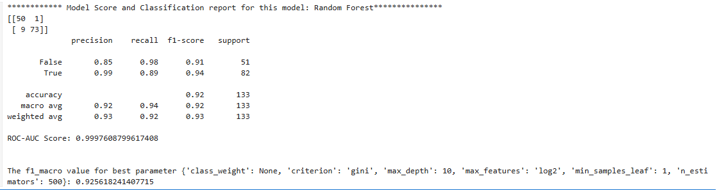

Decision Tree Classification Report Score:
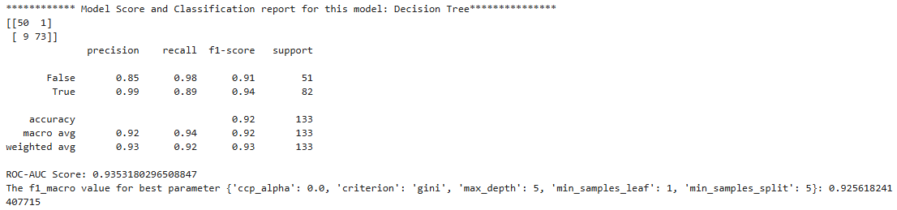

KNN Classification Report Score:
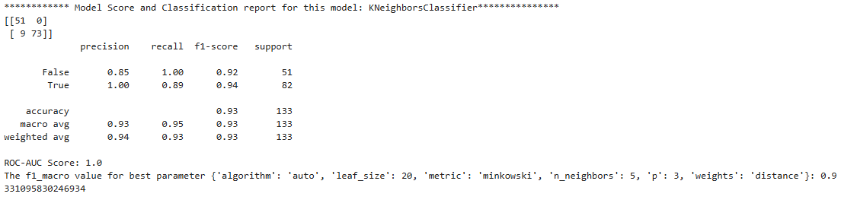
Logistic Regression:
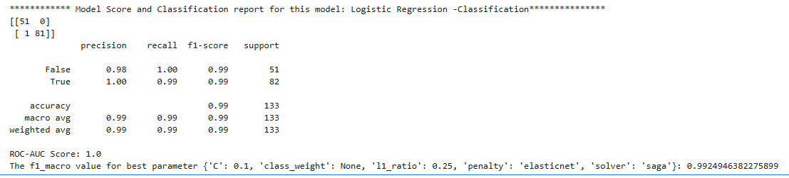
Naïve Bayes –
Gaussian
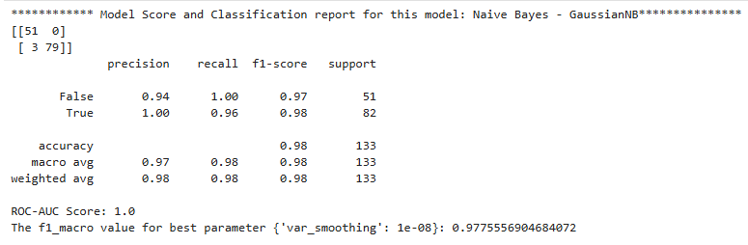
MultinomialDB
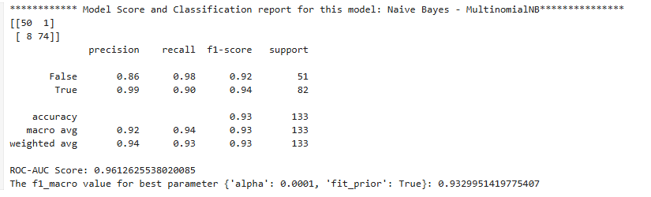

Bernouli
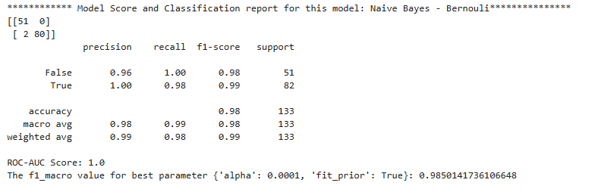
Complement DB
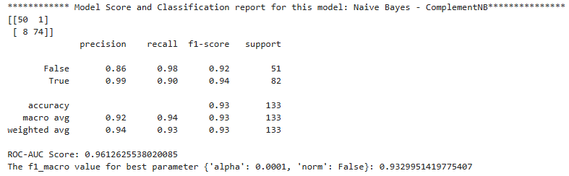

SVM – Classification
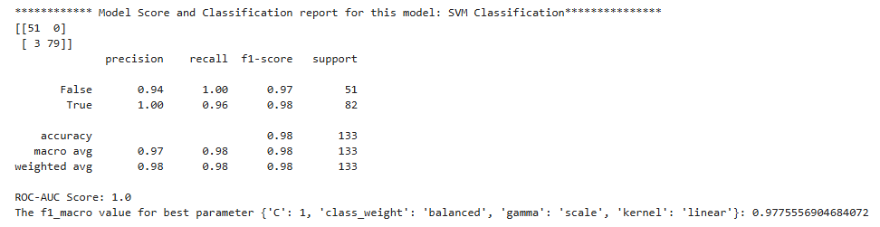

Best Model for This Dataset: -
Stage – 1 Selection
Model | CM Error Rate | Accuracy | Macro F1 | Weighted F1 | ROC | Error Pattern | Notes | Winner
Random Forest | (50,1)  (9,73) | 0.92 | 0.92 | 0.93 | 0.99 | 10 Errors
Logistic Regression | (51,0)  (1,81) | 0.99 | 0.99 | 0.99 | 1 | 1 Error | Best Overall | Winner
KNN | (51,0)  (9,73) | 0.93 | 0.93 | 0.93 | 1 | 9 Errors
Decision Tree | (50,1)  (9,73) | 0.92 | 0.91 | 0.93 | 0.93 | 10 Errors
Naive Bayes - ComplementDB | (50,1)  (8,74) | 0.93 | 0.93 | 0.93 | 0.96 | 9 Errors
Naive Bayes - Bernouli | (51,0)  (2,80) | 0.98 | 0.98 | 0.99 | 1 | 2 Errors |  | Winner
Naive Bayes - MultinomialDB | (50,1)  (8,74) | 0.93 | 0.93 | 0.93 | 0.96 | 9 Errors
Naive Bayes - GaussianDB | (51,0)  (3,79) | 0.98 | 0.98 | 0.98 | 1 | 3 Errors |  | Winner
SVC | (51,0)  (3,79) | 0.98 | 0.98 | 0.98 | 1 | 3 Errors |  | Winner

Ranking (based on combined view: weighted F1 → ROC → accuracy → error counts)
Model | CM Error Rate | Accuracy | Macro F1 | Weighted F1 | ROC | Error Pattern | Notes | Rank
Logistic Regression | (51,0)  (1,81) | 0.99 | 0.99 | 0.99 | 1 | 1 Error | Accuracy 0.99  Macro/Weighted -0.99  ROC -1 | 1
Naive Bayes - Bernouli | (51,0)  (2,80) | 0.98 | 0.98 | 0.99 | 1 | 2 Errors | Accuracy – 0.99  Macro F1 – 0.98  Weighted F1 -0.99  ROC Score -1  Error Rate - 2 | 2
Naive Bayes - GaussianDB | (51,0)  (3,79) | 0.98 | 0.98 | 0.98 | 1 | 3 Errors | Accuracy – 0.98  Macro F1 – 0.98  Weighted F1 -0.98  ROC Score -1  Error Rate -3 | 3
SVC | (51,0)  (3,79) | 0.98 | 0.98 | 0.98 | 1 | 3 Errors | Accuracy – 0.98  Macro F1 – 0.98  Weighted F1 -0.98  ROC Score -1  Error Rate -3 | 3

- Logistic Regression is best if priority is identifying more CKD disease since Recall for this 0.99
- Naïve Bayes Bernoulli is best alternative based on the below verdict.
• Accuracy: 0.98 — 98% of predictions correct.
• Positive class (True / disease)
- Precision ≈ 1.00 — when the model predicts disease, it is essentially always correct (no false positives).
- Recall ≈ 0.976 — it finds ~97.6% of real disease cases (misses 2 cases).
- F1 ≈ 0.988 — excellent balance for the positive class.
• Negative class (False / no disease)
- Precision ≈ 0.962 — most predicted non-disease are correct.
- Recall = 1.00 — it correctly identifies all actual non-disease cases (no false positives).
- F1 ≈ 0.981.
• Macro F1 = 0.98; Weighted F1 = 0.99; ROC = 1.00 — strong class-balanced and overall performance.

